1. YII Framework Version?
2. PHP?
3. MySQL?

# Claim process

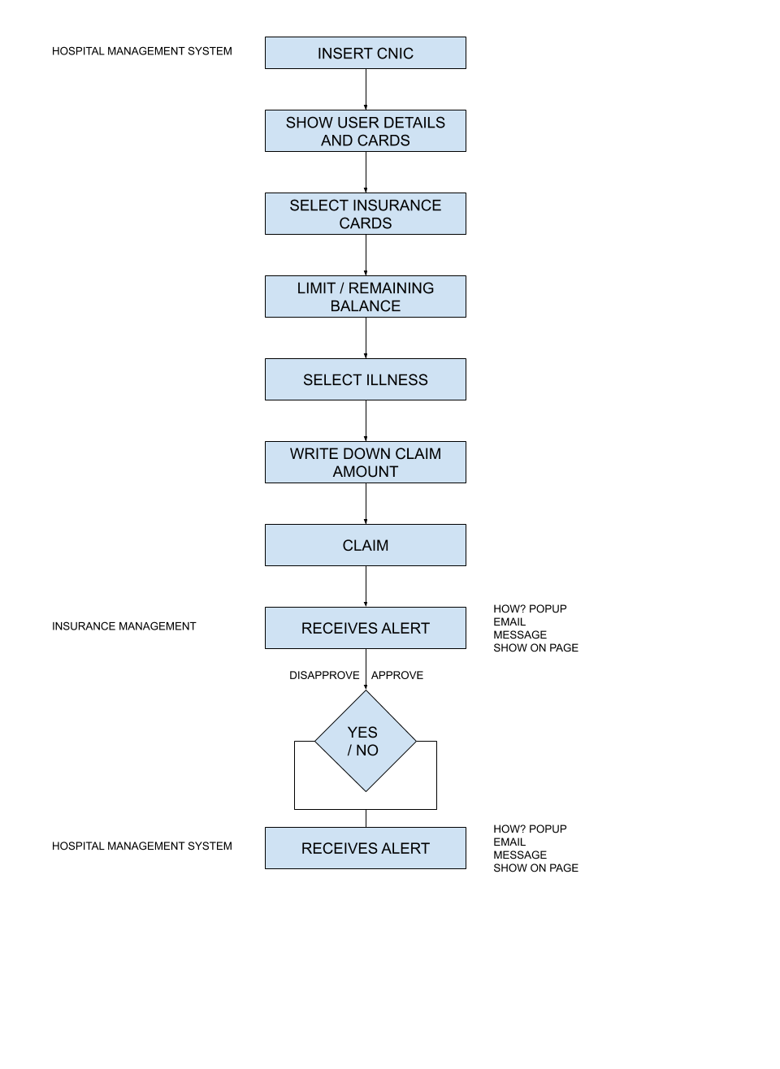

# Discharge Process

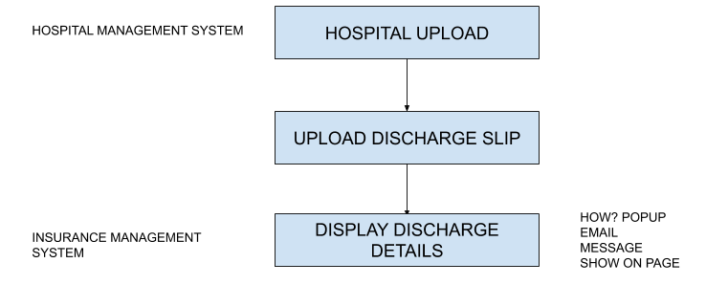

# Creating Packages

